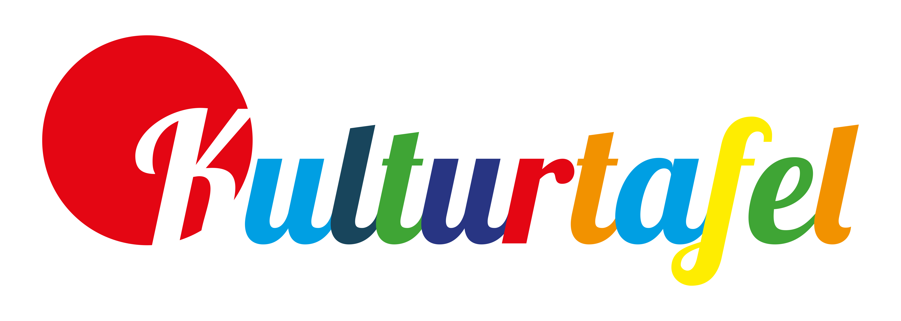

Application form
- Theatre
- Cabaret
- Film / Cinema
- Museums / Exhibitions
- Ballet / Dance
- Education / Discourse
- Literary reading
- Workshops / Creative work

Last name First name Date of birth

Street name Zip City

Email Phone Mobile Phone

My household includes adults / children
Year of birth (children)

- Folk music / Hits /
Brass music
- World music
- Classical music
- Jazz
- Choral music
- Sacred music
- Rock

- Pop
- Hip Hop
- Experimental music
- Sports events
- Excursions
- Guided city tour
- Events for children
kulturtafel@konstanz.de Wessenbergstr. 39
kulturtafel-konstanz.de 78462 Konstanz

Phone: 07531 900 988

I am interested in events within the following categories and would like to participate for free (you may choose as many as you want):

With my signature I agree that my name will be passed on to the respective organizers and my data will be saved in order to process the application form and to facilitate the mediation of tickets. An applicable proof of income or authorization (e.g. Sozialpass) will be attached to this application form and will be deleted and not be saved.

Place, Date Signature

Generally, tickets will be given away in pairs. However, due to private donations there might be single tickets available, which we would like to pass on to you, too:
- I am interested in single tickets.



